**Guided Solution for Tutorial 4**

**Question 4**

1. Remove the load RL

## **20 V**

5 Ω

10 

## **A**

## **B**

5 Ω

10 Ω

## **10 V**

Figure 1

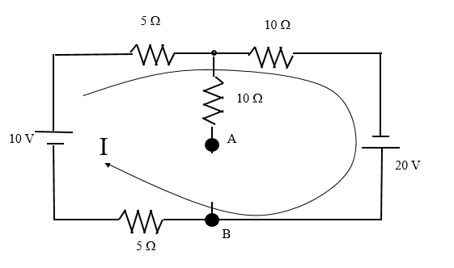

2. Calculate the current I

3. Draw the directional loop to form KVL equation to find VTH as shown in red.

4. Indicate the polarity of VTH and the voltage drop across the components within this loop.

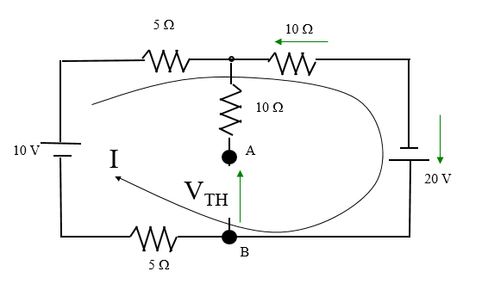

5. Write down the KVL equation VTH -10I +20 =0

6. To find RTH replace all the voltage sources in Figure 1 with a short circuit.

7. Calculate the equivalent resistance across AB.

7. Draw the equivalent circuit and connect RL across AB.

8. Calculate VRL.